PAR Environment Set Up

- Install Jruby v9.1.15.0 and make sure path set up is done in system environment variables.

JRUBY_HOME = Jruby installation path in you machine
Ex: JRUBY_HOME = F:\Installations\jruby-9.1.15.0;

- Verify the version of Jruby using below command in command prompt
jruby -v

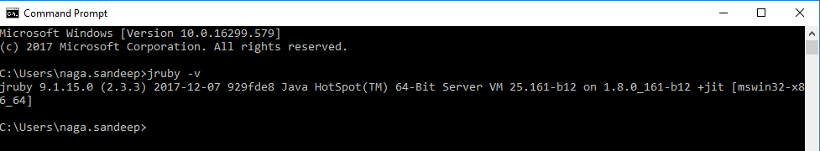

- Install torquebox gems using below command
jruby -S gem install torquebox

- Install torquebox server gems using below command
jruby -S gem install torquebox-server

- Install Rails using below command
jruby -S gem install rails

- Run below command to install all dependent gems configured in the project
bundle install

- Uninstall openssl 0.9.4v gem and install 0.9.6v gem using below commands.
gem uninstall jruby-openssl-0.9.4
gem install jruby-openssl -v 0.9.6

- Open Gemfile.lock and modify the version of jruby-openssl (0.9.4) to jruby-openssl (0.9.6)

- Now deploy the application using below command
torquebox deploy

- Now run below command to start the application.
torquebox run

connect to USS VPN

http://localhost:8080/par/

user.0
biascorp

